**Assignment**

**Aim:** Design and develop custom Application (Mini Project) using Salesforce Cloud.

**Objective:** To create a custom application on Salesforce Lightning platform.

**Theory:**

**1. Salesforce:**

Salesforce is a cloud computing service as a software (SaaS) company that specializes in customer relationship management (CRM). Salesforce's services allow businesses to use cloud technology to better connect with customers, partners and potential customers. The software has become the number one for customer success and help businesses track customer activity, market to customers and many more services. Salesforce is a customer relationship management solution that brings companies and customers together. It is one integrated CRM platform that gives all your departments — including marketing, sales, commerce, and service — a single, shared view of every customer.

**How Does Salesforce Work?**

Salesforce is a CRM platform and also a centralized platform for managing customer accounts, sales leads, activities, customer support cases, and more. Users can access Salesforce through a web browser, mobile app, or desktop application. Salesforce allows users to customize and create custom objects, fields, processes, and reports and integrate them with other software products. Salesforce also provides marketing automation and Artificial Intelligence (AI) capabilities.

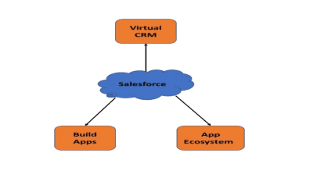

**2. Salesforce Lightning Experience:**

Salesforce Lightning Experience is simply referred to as “Lightning”. When working with lightning Salesforce we will learn about different Salesforce lightning topics like Lightning Login, Lightning App Builder, and Lightning for Outlook, Salesforce Lightning Components, Lightning Sync and many more. Some of them are applicable in Lightning Experience only, but some others will work in both Lightning Experience and older Classic user interfaces. Lightning Sync is used to sync your user contacts and events between your email servers with Salesforce.

### Salesforce Lighting features

Here are some key Salesforce Lightning features:

* **Experience Builder** is a graphical user interface ([GUI](https://www.techtarget.com/whatis/definition/GUI-graphical-user-interface)) optimized for speed. Administrators can build robust communities using Lightning [templates](https://www.techtarget.com/whatis/definition/template) and components following a visual [no-code](https://www.techtarget.com/searchsoftwarequality/definition/no-code) development approach.
* **Lightning App Builder** follows a no-code development approach providing drag-and-drop capabilities to facilitate app creation and customization.
* **Lightning Component Framework** includes tools and extensions that enable the development of reusable components and standalone apps and Salesforce Mobile App customizations.
* **Design System** offers style guides and user experience ([UX](https://www.techtarget.com/searchcio/definition/UX-user-experience)) best practices for app development.
* **Lightning Connect** is an integration tool that makes it easier for Salesforce apps to consume data from any external source that conforms to the Open Data Protocol

Step 1: Log into Salesforce Developer account.

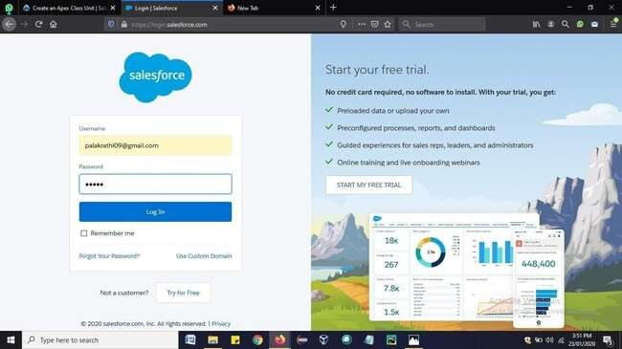

Step 2: Open Salesforce Lightning platform and click on Object Manager => Create => CustomObject.

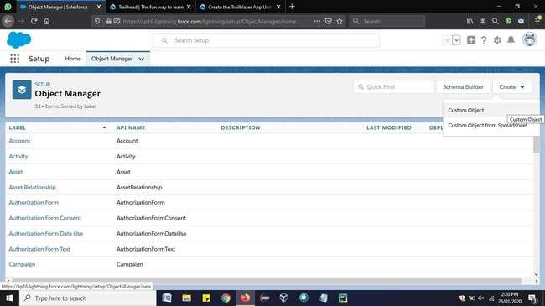

Step 3: Fill in the required fields and under Optional Features, select **Allow Reports** and **Allow Activities**. Click **Save.**

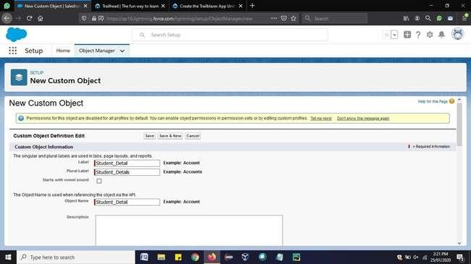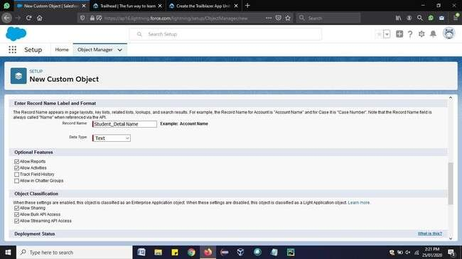

Step 4: Now, Click on Fields & Relations => New.

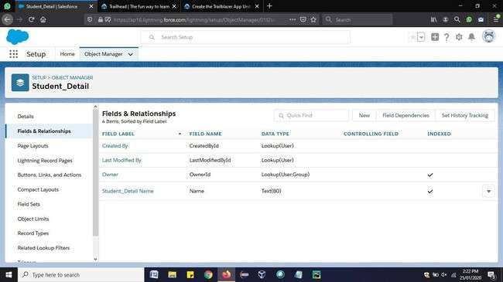

Step 5: Then select option ―Email‖ and click Next-> Next -> Save.

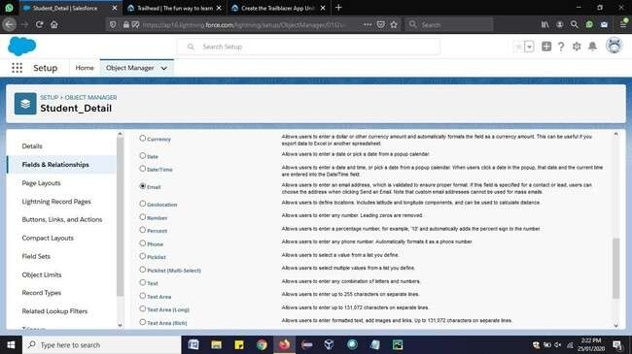

Step 6: Similarly. Repeat steps 4 and 5 to add more fields like Phone, Date of Birth. This is how the custom object will have the various fields.

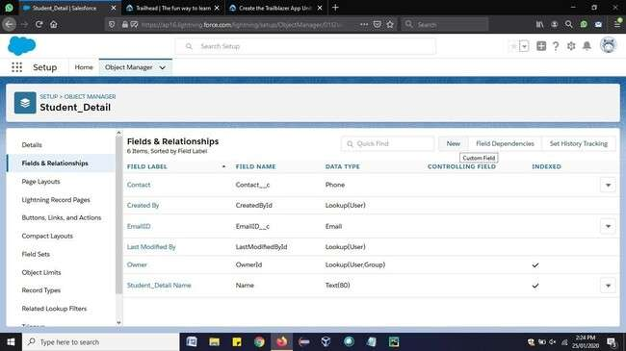

Step 7: Now go to Home => search for ―Tabs‖. Click on New.

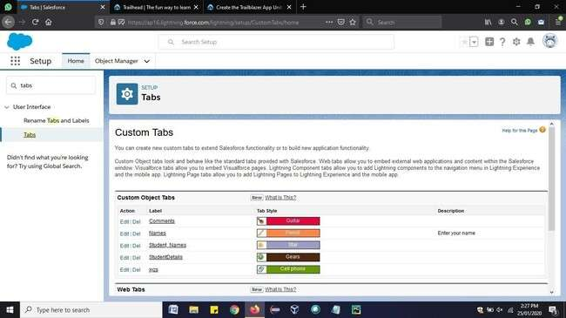

Step 8: Enter the Object name and select any icon for tab style. Leave all defaults as it is. Click

**Next, Next**, and **Save**.

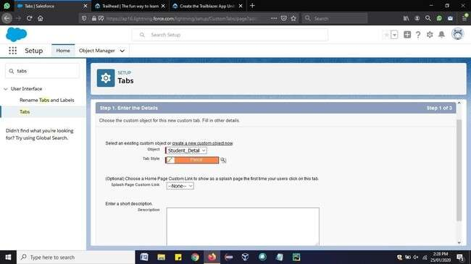

Step 9: In Setup, click **Home**. Enter ―App Manager‖ in Quick Find and select **App Manager**. Click **New Lightning App**.

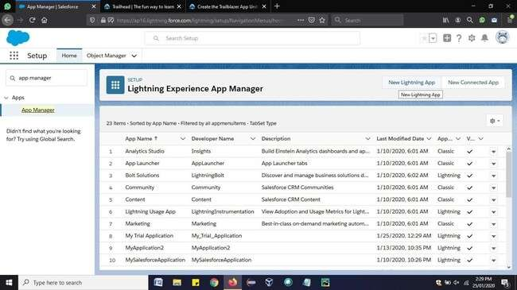

Step 10: Define the new Lightning app as follows:

App Name: Student Details Manager

Developer Name: Student_Details_Manager. Click **Next**.

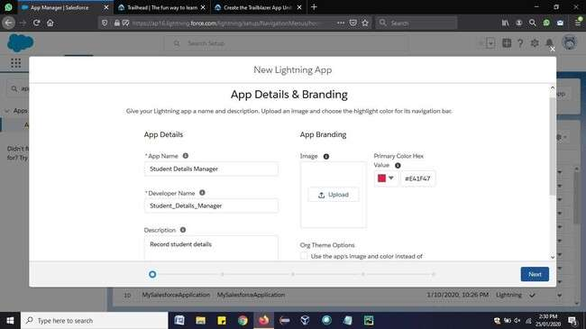

Step 11: On the App Options screen, leave the defaults as is and click **Next**. On the Utility Itemsscreen, leave the defaults as is and click **Next**. On the Navigation Items screen, select **Student_Detail** and move them to the Selected Items box. Then click **Next**.

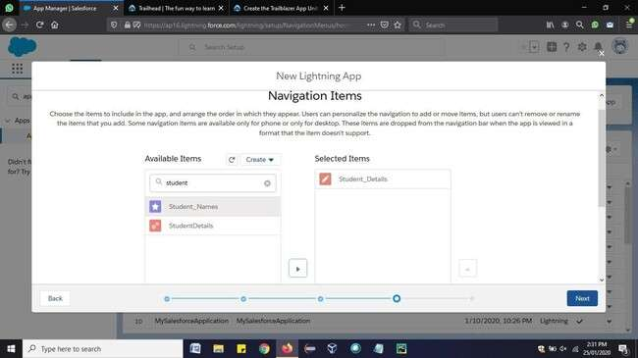

Step 12: On the Assign to User Profiles screen, select **System Administrator** and move it to Selected Profiles. Then click **Save & Finish**.

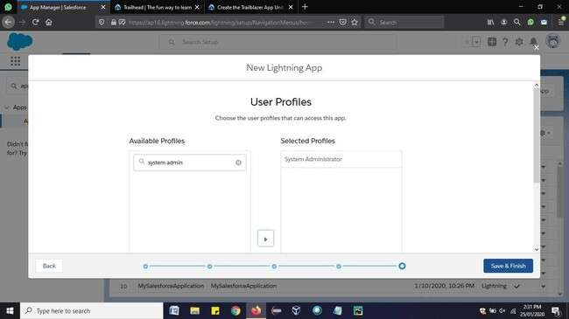

Step 13: Click on App launcher and Open the custom application created.

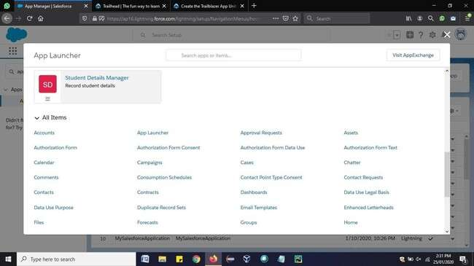

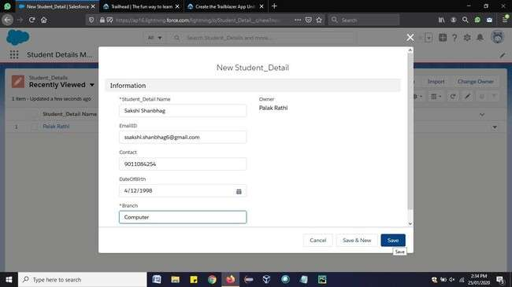

Step 14: Click on Student_Details => New => fill the specified details and copy the URL.

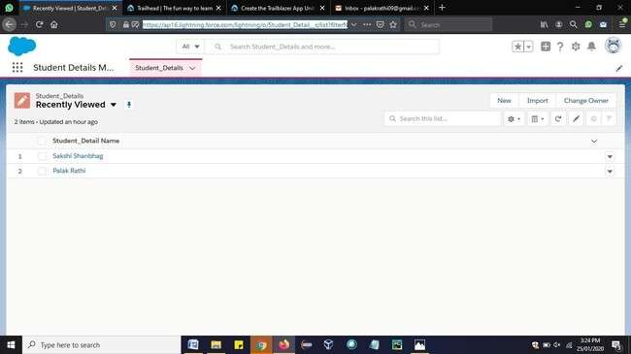

Step 15: Open Google Chrome new Tab => More Tools => Developer Tools and then paste the URL of the application, copied in the previous step.

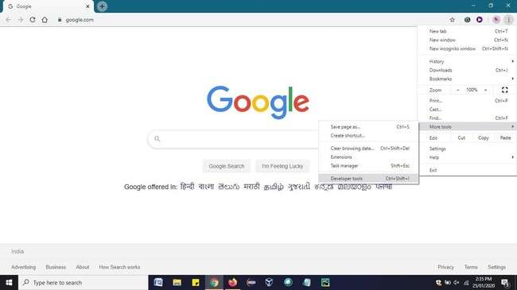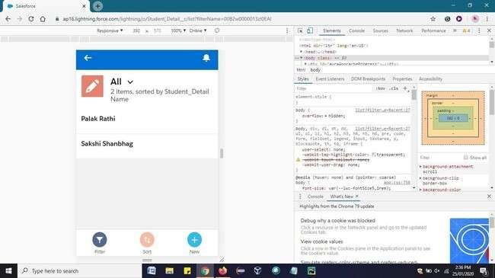

Conclusion: We have learnt to create custom application using salesforce Lightning platform.

**NOTE: THIS IS JUST FOR THE REFERENCE THE SCREENSHOTS OF THE OUTPUTS SHOULD BE OF UR OWN APPLICATION( CREATE A NEW APPLICATION OF UR OWN LIKE BANKING APP, EMPLOYEE DETAILS SHOPPING MALL ETC)**